**Experiment – 11**

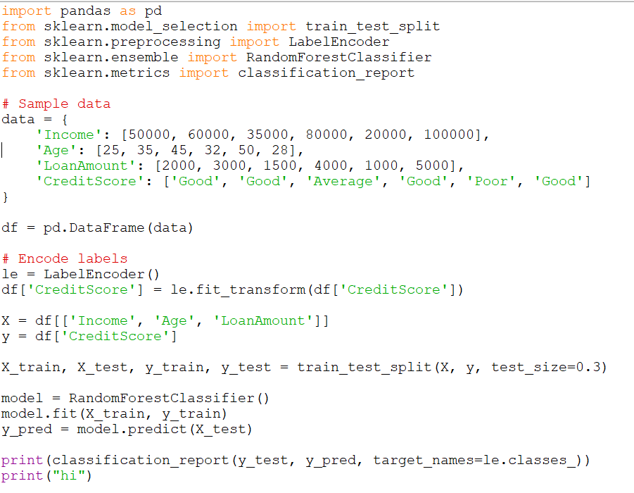

**Output**

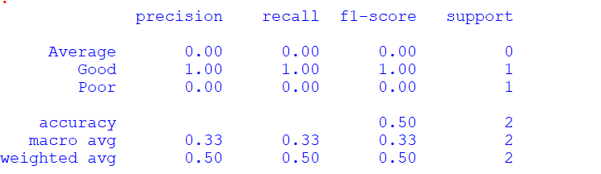

**Experiment – 12**

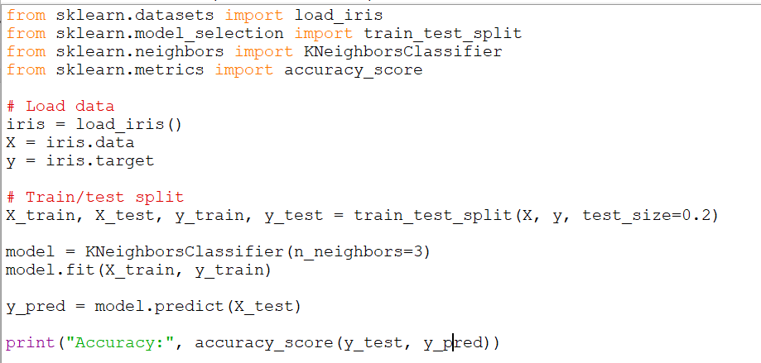

**Output**



**Experiment – 13**

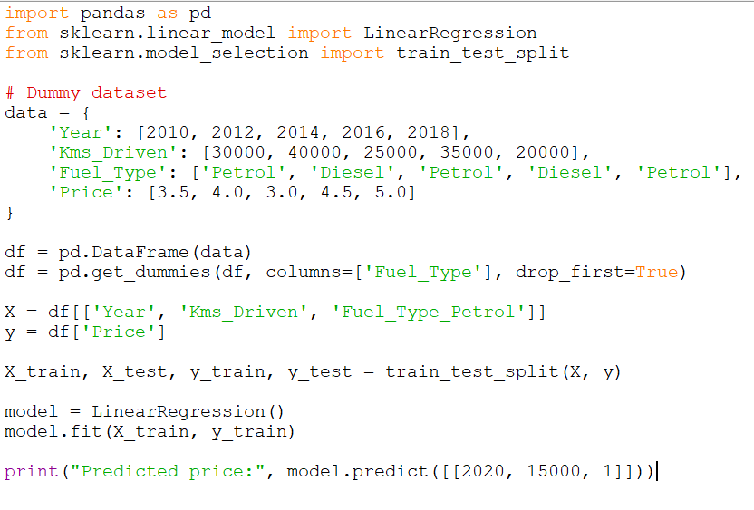

**Output**



**Experiment – 14**

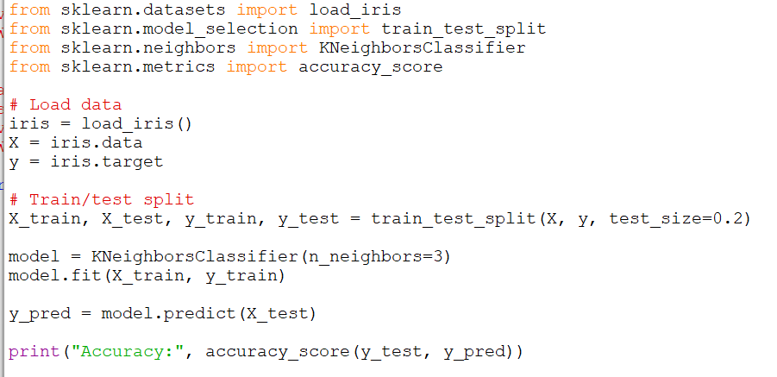

**Output**



**Experiment – 15**

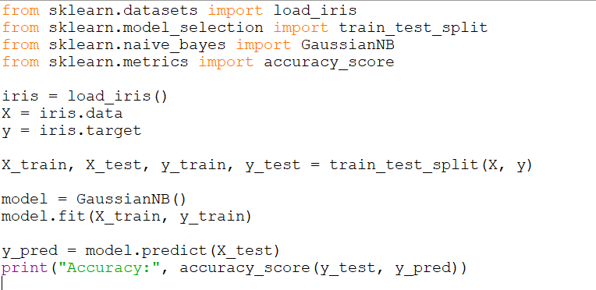

**Output**



**Experiment – 16**

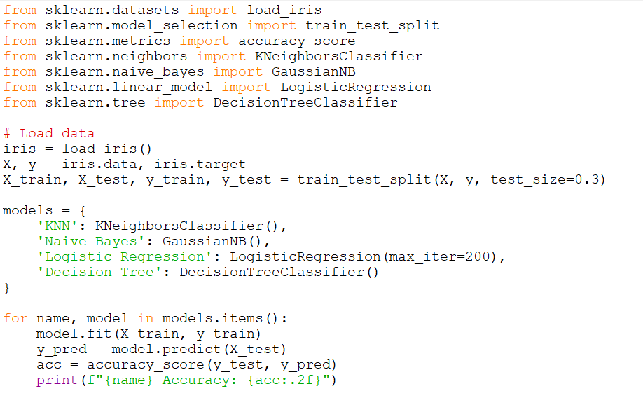

**Output**

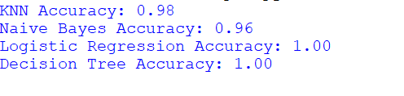

**Experiment – 17**

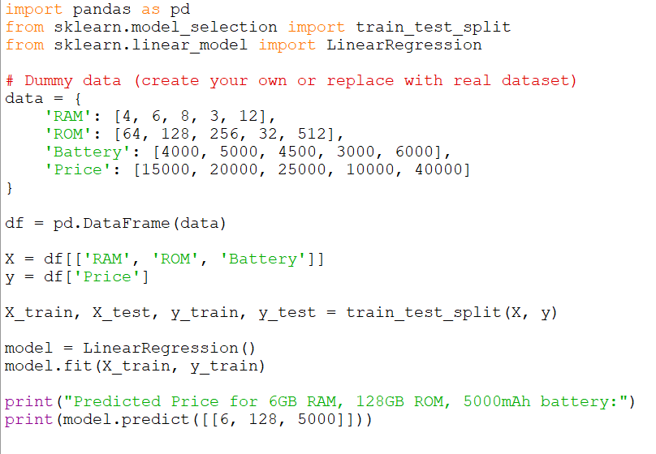

**Output**



**Experiment – 18**

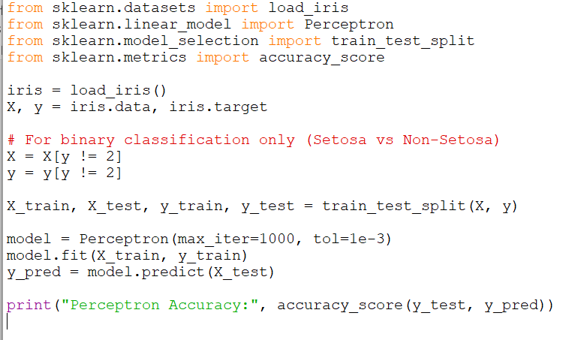

**Output**



**Experiment – 19**

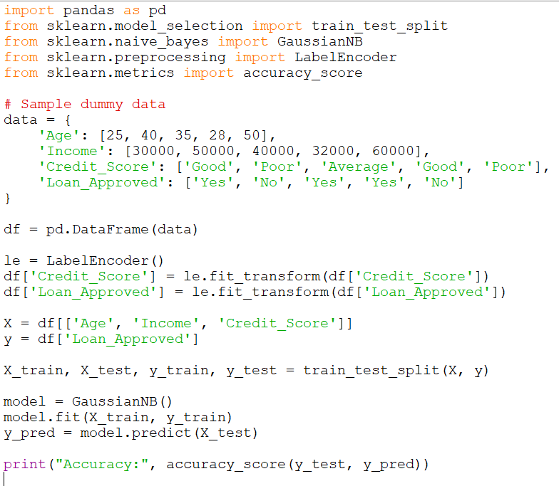

**Output**



**Experiment – 20**

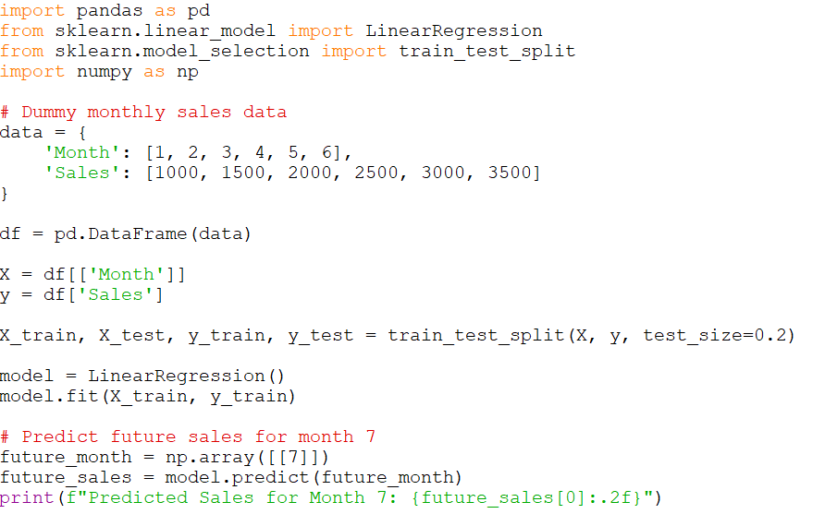

**Output**

